Econ 201
HW 4
Monetary Policy
- What will happen to the interest rates banks charge businesses and consumers if the federal funds rate falls? Explain your answer.

- If equilibrium real GDP is less than full employment real GDP, what should the Fed do
- About the discount rate?
- The reserve requirement?
- With bonds?
- About interest payments the Fed offers on bank reserves? (Assume the Fed currently pays interest on bank reserves.)

- The Fed is worried about inflation. The Fed will respond by increasing/decreasing the money supply/money demand? (Circle the appropriate answers.)

Draw the appropriate change on the graph below.
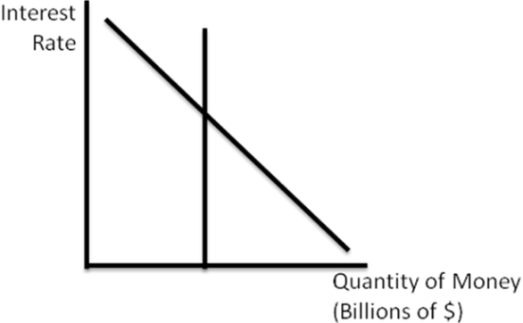
Equilibrium interest rates will increase/decrease.
The quantity of money people will hold will increase/decrease.

- Consider how the scenario in the previous question will affect the market for loanable funds. Draw the appropriate changes on the graph, and circle the appropriate answers in the statements below.

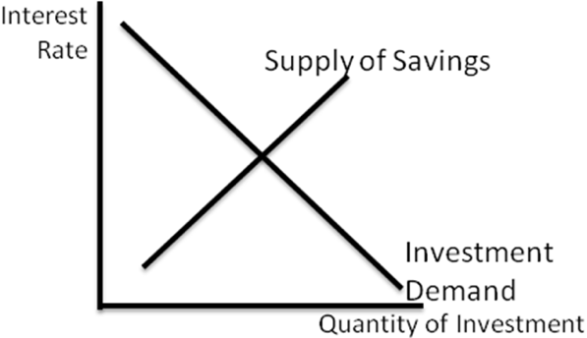
Equilibrium interest rates will increase/decrease.
The quantity of investment spending will increase/decrease.

- Consider how these changes will affect the real economy. Draw the appropriate changes on the graph, and circle the appropriate answers in the statements below.
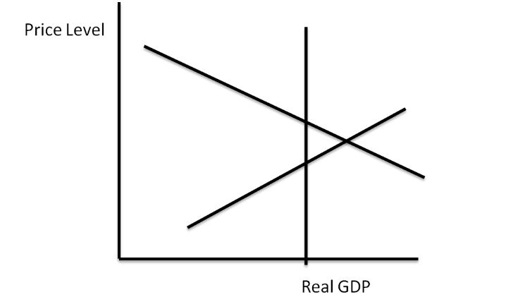
The price level will increase/decrease.
Real GDP will increase/decrease.

- Based on your answers above, as inflation falls, unemployment will __________.

- The Fed may sometimes “closes the discount window,” suspend lending to member banks. What effect would this have on the federal funds rate? How would this affect the money supply? What affect would this have on real GDP and the price level? Explain your answers.

- On the graph below, we assume that the money demand curve flattens out when interest rates get very low. What will happen to interest rates if the Fed increases the money supply? Will monetary policy be effective at increasing aggregate demand under these circumstances? Explain.
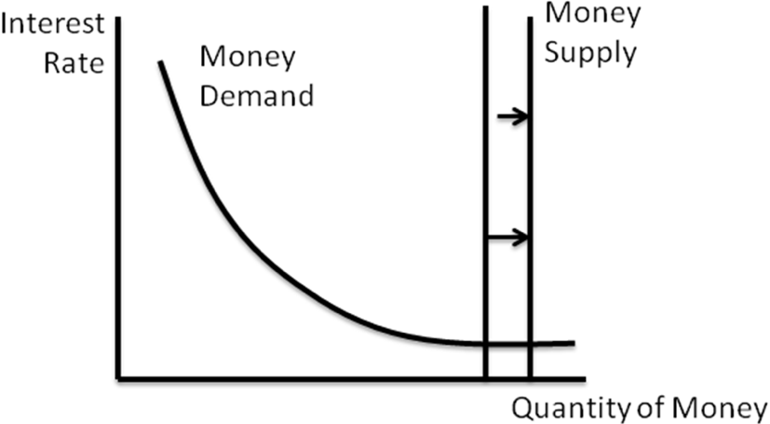
- The simple deposit multiplier is calculated as 1/(required reserve ratio). This assumes that banks will not hold any excess reserves. What happens to the multiplier if banks decide to hold excess reserves? Explain.

Phillips Curve
- (a) If the inflation rate increases in the short run, the unemployment rate will___________ in the short run.

- If the inflation rate increases in the long run, the unemployment rate will _________ in the long run.

- Which of these represents a short run Phillips curve and which is the long run? Explain.
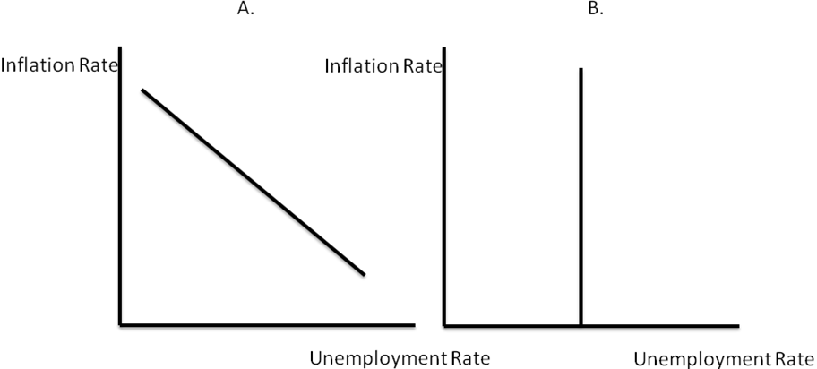

- Assume the Phillips curve below applies to the economy in the short run.
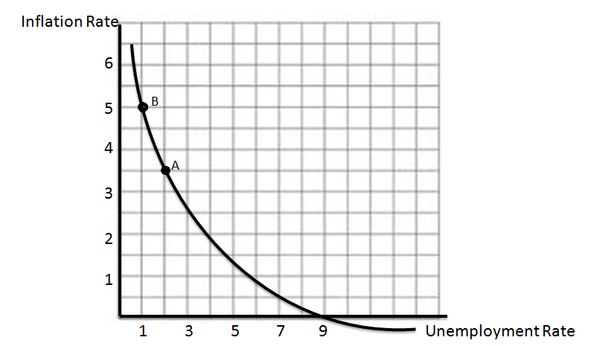
- If the economy is currently at point B, the inflation rate is ____________ and the unemployment rate is __________.
- If the central bank wants to move the economy from point B to point A, it will reduce inflation by _________ but increase unemployment by __________.
- The central bank should increase/decrease the money supply. It should buy/sell government bonds, raise/lower reserve requirements, and raise/lower interest rates.
- The economy will experience deflation when the unemployment rate rises above:
- Assume the natural rate of unemployment in this economy is 4%. Draw the long run Phillips curve on the graph.
- If the natural rate of unemployment is 4%, and the economy is currently at point A. is the economy experiencing an inflationary gap, a recessionary gap, or neither? Explain.

- Adaptive expectations are different than the rational expectations model discussed in the text. Adaptive expectations are formed based on past experience, not large amounts of information. Which of the following shows adaptive expectations? Which shows rational expectations? Explain.

  - Marcus examines government-published data to determine whether to adjust his prices for the next month.

  - Inflation has been relatively low, so Lucinda doesn’t really worry about increasing the prices she charges.

- For the scenarios below:
  - The Fed consistently adopts significant expansionary monetary policy.
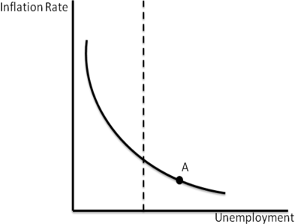
(i) If the economy is initially at point ‘A’, we need to increase/decrease inflation to return the economy to full employment.
(ii) Draw the shift, if any, in the short run Phillips Curve in response to the scenario above.
(iii) After the shift (if there is one), it will take a greater/lower/the same level of inflation to return the economy to full employment.
(c) The Fed announces a disinflation policy, but no one believes them.
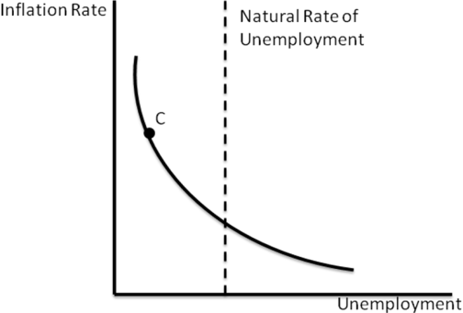
(i) If the economy is initially at point ‘C’, we need to increase/decrease inflation to return the economy to full employment.
(ii) Draw the shift, if any, in the short run Phillips Curve in response to the scenario above.
(iii) After the shift (if there is one), it will take a greater/lower/the same level of inflation to return the economy to full employment.
International Trade
- Based on the graph below, draw the line corresponding to the world price on the country graph. Complete the table. 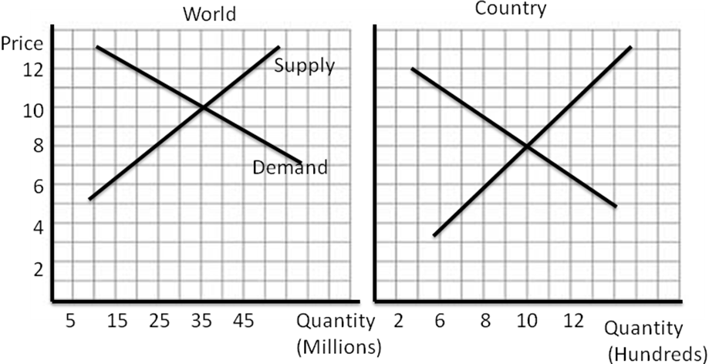
World Equilibrium Price
World Equilibrium Quantity
Domestic Equilibrium Price
Domestic Equilibrium Quantity
World Price
Export or Import?
Quantity of Exports/Imports
Quantity Produced Domestically
Quantity Consumed Domestically

- Assume a country currently allows free trade. The country is currently a net importer of good x. The government wants to export good x. Which of the following is the best way to accomplish this? Explain your answer.
- Tariff on imports
- Subsidizing domestic producers
- Tax rebates to domestic consumers who purchase the good.

- Use the supply and demand data to complete the table. Complete the no-trade outcome. Assume the world price of the good is $10. Complete the “With Free Trade” column. Then assume the government imposes a 50% tariff and complete the relevant column. Graph supply and demand. Graph the world price. Graph the tariff.
Price | Quantity Demanded | Quantity Supplied
$5 | 5000 | 800
10 | 4000 | 1200
15 | 3000 | 1600
20 | 2000 | 2000
25 | 1000 | 2400
30 | 500 | 3000

 | Without Trade | With Free Trade | With 50% tariff
Price
Quantity Consumed Domestically
Quantity Produced Domestically
Import/Export/Neither
Quantity Imported/Exported
Tax Revenue From Tariff
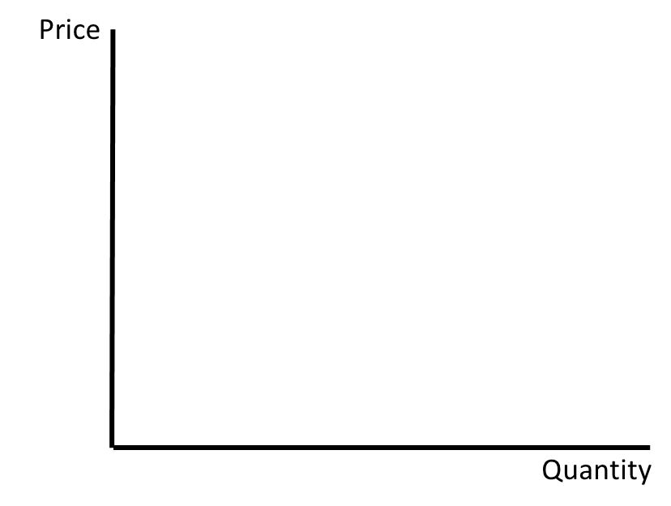

Exchange Rates
- For each of the following,
(i)Draw the appropriate curve shift.
(ii) Explain your decision.
(iii) State what will happen to the equilibrium exchange rate.
(iv)State what will happen to the equilibrium quantity of $ exchanged.
(v) State what will happen to the quantity of exports.
(vi) State what will happen to the quantity of imports.

- Demand for U. S. goods in Europe decreases.
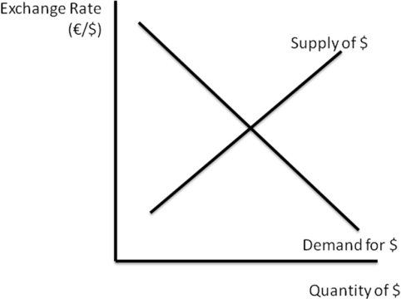
- The Fed increases the money supply.
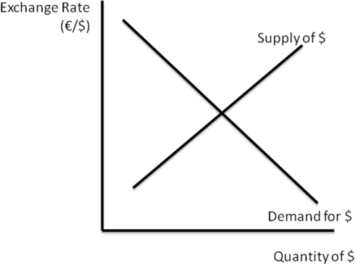

- The European Central Bank is worried that the Fed is increasing the money supply. If the ECB wishes to protect exports from the European Union, it should _______________ dollars and ___________ Euros. Explain how this would help.

- Use the data below to complete the table and graph the demand for dollars in the foreign exchange market. Assume the price of the good below is $20.
Price in € | Quantity of exports demanded | Exchange Rate (€/$)* | $ Demanded
 | 500 | .25
 | 400 | .5
 | 300 | .75
 | 200 | 1
